**Pâtisserie et Chocolat Limited**

**Premium Products from**

**Clark Factory**

**Effective from 1st November 2023**

 

**Pâtisserie et Chocolat Limited**

**A subsidiary of Baker & Patissier Limited**

301-303 Corporation Square, 8 Lam Lok Street, Kowloon Bay, Hong Kong Tel: 2754 2355 Fax: 2795 7473

Email: [office@baker-patissier.com](mailto:office@baker-patissier.com)

PCL 1

**Pâtisserie et Chocolat Limited FROZEN BAKERY PRODUCTS**

**黑玫瑰急凍麵包**

***Premium Quality for VIP customers !!! Hand Made Mini VIP Rolls - Frozen***

|  |  |  |  |  |
| --- | --- | --- | --- | --- |
| **CODE** | **APP. WEIGHT** | **DESCRIPTION** | **STYLE** | **PACKAGING** |
|  |  | ***HANDMADE MINI VIP ROLLS***  ***手 製 迷 你 VIP 包*** |  |  |
| FRBA763A | 27g | MUSTARD SEED 芥 末 籽 包 | BF | 50 |

Sandwich Bread - Frozen

|  |  |  |  |  |
| --- | --- | --- | --- | --- |
| **CODE** | **APP. WEIGHT** | **DESCRIPTION** | **STYLE** | **PACKAGING** |
|  |  | ***Sandwich Bread***  ***三文治麵包*** |  |  |
| FRC1011 | 105g | TURKISH BREAD PLAIN  土 耳 其 包 | BF | 40 |
| FRC1041 | 110g | ARTISAN TRADITIONELLE TORDU  紐 紋 法 包 | BF | 28 |
| FRC1020 | 125g | ARTISAN BAGUETTE SMALL  特 式 手 製 法 包 - 細 | BF | 28 |

Defrost at room temperature for 30 minutes, bake at 220°C for 1 minute, serve hot.

於室温解凍 30 分鐘, 入 220°C 爐焗 1 分鐘 , 趁熱用餐。

Pizza Base - Frozen

|  |  |  |  |  |
| --- | --- | --- | --- | --- |
| **CODE** | **APP. WEIGHT** | **DESCRIPTION** | **STYLE** | **PACKAGING** |
| **NEW!!!** |  | ***Pizza Base***  ***薄 餅 底*** |  |  |
| FR468P1 | 160g | WHITE SOUR DOUGH PIZZA BASE 23cm  薄 餅 底 (白) | BF | 14 |

**BF - Bake Frozen (80% baked)**

 = Contains Milk = Contains Egg

Pâtisserie et Chocolat Limited

A subsidiary of Baker ＆ Patissier Limited Effective from 1st March 2023

**Baking Instructions**



1st November 2019

**Croissants and Danish**

1. Place the Danish and Croissants in the baking tray, leaving enough room for the product to double in size. For best results, use perforated trays.
2. Preparation: Croissants - thaw at room temperature (approximately 60 minutes depending on size). Danish - baked straight from freezer to oven.
3. Brush the Danish and Croissants with egg wash and bake without steam.
4. Place in PREHEATED oven and bake until golden brown.
5. Bake the Danish and Croissant according to the specified temperature and baking time below.

|  |  |  |  |  |
| --- | --- | --- | --- | --- |
| **PRODUCT** | **PRODUCT SIZE** | **DEFROSTING TIME** | **CONVECTION OVEN** | |
| **Temperature** | **Baking Time** |
| **Danish** | 30g - 40g | N/A | 170°C | 17 mins |
| **Croissants** | 15g | 1Hour | 170°C | 15 mins |
| 25g - 30g | 170°C | 16 mins |
| 40g - 50g | 170°C | 18 mins |
| 60g - 70g | 170°C | 20 mins |
| 90g - 110g | 170°C | 23 mins |

The temperature will vary according to the type and efficiency of the oven available.

Adjust accordingly if needed.

*If doing more than one bake, please ensure that the oven returns to the correct temperature between bakes. The Danish should be brushed with clear glaze and decorated with icing or toppings of choice.*

**Pâtisserie et Chocolat Limited**

302 Corporation Square, No.8 Lam Lok Street, Kowloon Bay, Kowloon, Hong Kong Tel: 2754 2355 / Fax: 2795 7473 Email: [office@baker-patissier.com](mailto:office@baker-patissier.com)

PCL 3



|  |  |  |  |
| --- | --- | --- | --- |
| **CODE** | **WEIGHT (GR)** | **DESCRIPTION** | **PACKING (PIECES)** |
|  |  | ***FROZEN BUTTER CROISSANT***  **牛 油 牛 角 酥** |  |
| FRC104 | 30 | BUTTER CROISSANT STRAIGHT  牛 油 牛 角 酥 – 長 形 | 260 |
|  |  |  |  |
| FRC181P | 40 | AOP FRENCH BUTTER CROISSANT STR.  AOP 法 國 牛 油 牛 角 酥 – 長 形 | 200 |
| FRC113 | 65 | AOP FRENCH BUTTER CROISSANT STR.  AOP 法 國 牛 油 牛 角 酥 – 長 形 | 90 |
|  |  |  |  |
| FRC124 | 30 | WHOLE WHEAT CROISSANT STR.  全 麥 牛 油 牛 角 酥 – 長 形 | 260 |

= Contains Milk = Contains Egg



a

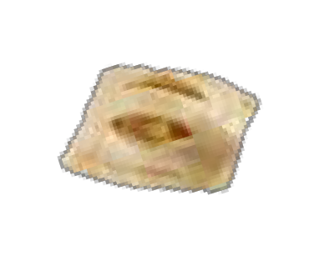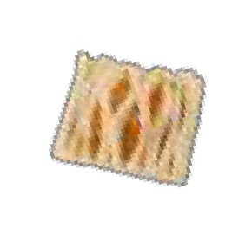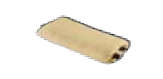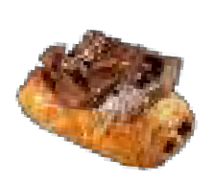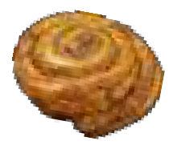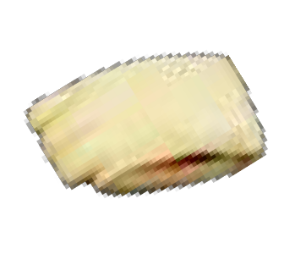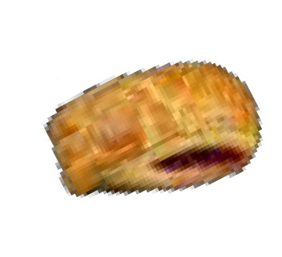

**CODE**

**WEIGHT (GR)**

**DESCRIPTION**

**STYLE**

**PACKING (PIECES)**

***90G LARGE DANISH RTB***

**丹 麥 酥*–* 大**

FRD201

90

PAIN AU CHOCOLAT - LARGE

朱 古 力 酥 – 大

RTB

100

***30G MINI DANISH RTB***

**丹 麥 酥*-* 細**

FRD202

30

MINI PAIN AU CHOCOLAT

朱 古 力 酥 - 細

RTB

120

FRD216

30

MINI CINNAMON SNAIL

肉 桂 卷 - 細

RTB

120

FRD220

30

MINI MANGO DANISH

芒 果 丹 麥 酥 - 細

RTB

120

FRD223

30

MINI CUSTARD RAISIN SNAIL

奶 黃 提 子 卷 - 細

RTB

120

FRD224

30

MINI CUSTARD CHOCOLATE DROPS SNAIL

奶 黃 朱 古 力 卷 - 細

RTB

120

FRD228

30

MINI STRAWBERRY DANISH

草 莓 丹 麥 酥 - 細

RTB

120

$3.2

$387

FRD231

30

MINI BLUEBERRY DANISH

藍 啤 梨 丹 麥 酥 - 細

RTB

120

$3.5

$416

FRD241

30

MINI APPLE POCKET

蘋 果 袋 - 細

RTB

120

$3.2

$378

FRD243

30

MINI RASPBERRY BEAR CLAW

覆 盆 子 酥 - 細

RTB

120

$3.5

$416

FRD245

30

MINI APRICOT LATTICE

杏 桃 酥 - 細

RTB

120

$3.0

$365



**CODE**

**WEIGHT (GR)**

**DESCRIPTION**

**STYLE**

**PACKING (PIECES)**

***90G LARGE DANISH RTB***

**丹 麥 酥*–* 大**

FRD201

90

PAIN AU CHOCOLAT - LARGE

朱 古 力 酥 – 大

RTB

100

***30G MINI DANISH RTB***

**丹 麥 酥*-* 細**

FRD202

30

MINI PAIN AU CHOCOLAT

朱 古 力 酥 - 細

RTB

120

FRD216

30

MINI CINNAMON SNAIL

肉 桂 卷 - 細

RTB

120

FRD220

30

MINI MANGO DANISH

芒 果 丹 麥 酥 - 細

RTB

120

FRD223

30

MINI CUSTARD RAISIN SNAIL

奶 黃 提 子 卷 - 細

RTB

120

FRD224

30

MINI CUSTARD CHOCOLATE DROPS SNAIL

奶 黃 朱 古 力 卷 - 細

RTB

120

FRD228

30

MINI STRAWBERRY DANISH

草 莓 丹 麥 酥 - 細

RTB

120

FRD231

30

MINI BLUEBERRY DANISH

藍 啤 梨 丹 麥 酥 - 細

RTB

120

FRD241

30

MINI APPLE POCKET

蘋 果 袋 - 細

RTB

120

FRD243

30

MINI RASPBERRY BEAR CLAW

覆 盆 子 酥 - 細

RTB

120

FRD245

30

MINI APRICOT LATTICE

杏 桃 酥 - 細

RTB

120

**RTB - Ready to bake / Fully proven**

= Contains Milk = Contains Egg



**CODE**

**WEIGHT**

**Pâtisserie et Chocolat Limited FROZEN BAKERY PRODUCTS**

**黑玫瑰急凍麵包**

**DESCRIPTION**

**PACKING**

**(GR) STYLE**

***READY-TO-USE DOUGH (FULLY-PROVEN)***

**即 用 麵 糰 塊**

LARGE DANISH SQUARE (12cmX12cm)

**(PIECES)**

FRD256 65

FRD505 30

FRD506 30

FRD507 30

FRD522 20

丹 麥 酥 方 塊 - 大

***30G MINI BREAKFAST SELECTION***

**丹 麥 酥 *-* 精 選**

**BREAKFAST SELECTION “A”**

**早 餐 精 選 A**

MINI BLUEBERRY DANISH

藍 啤 梨 丹 麥 酥 - 細 MINI APRICOT LATTICE

杏 桃 酥 - 細

MINI CUSTARD RAISIN SNAIL

奶 黃 提 子 卷 - 細

**BREAKFAST SELECTION “B”**

**早 餐 精 選 B**

MINI STRAWBERRY DANISH

草 莓 丹 麥 酥 - 細

MINI APPLE POCKET

蘋 果 袋 - 細

MINI PINEAPPLE DANISH

菠 蘿 丹 麥 酥 - 細

**BREAKFAST SELECTION “C”**

**早 餐 精 選 C**

MINI PAIN AU CHOCOLAT

朱 古 力 酥 - 細

MINI CINNAMON SNAIL

肉 桂 卷 - 細

MINI RASPBERRY BEAR CLAW

覆 盆 子 酥 - 細

***20G EXTRA MINI BREAKFAST SELECTION***

**丹 麥 酥 *-* 精 選**

**EXTRA MINI DANISH SELECTION A**

**特 級 迷 你 丹 麥 酥 精 選 A**

EXTRA MINI PAIN AU CHOCOLAT

朱 古 力 酥

EXTRA MINI APPLE POCKET

蘋 果 袋

EXTRA MINI RASPBERRY DANISH

覆 盆 子 酥

EXTRA MINI CINNAMON SNAIL

肉 桂 卷

RTB

RTB

RTB

RTB

RTB

100

120

40

40

40

120

40

40

40

120

40

40

40

200

50

50

50

50

**RTB - Ready to bake / Fully proven**

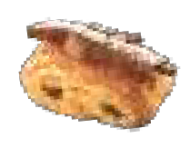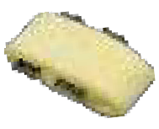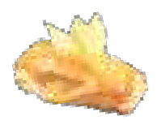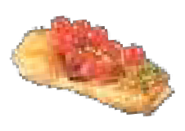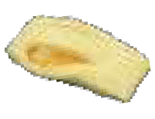

= Contains Milk = Contains Egg



### FROZEN PORTUGUESE TART

|  |  |  |  |
| --- | --- | --- | --- |
| **CODE** | **DESCRIPTION** | **APP. SIZE** | **PACKAGING** |
|  |  |  |  |
| **FR659** | FROZEN PORTUGUESE TART SHELL | Weight: 18gr/pc Dia: 6.5 x H: 2.5cm | 140 pcs |
|  |  |  | | |
| **Storage condition: -18°C (Shelf Life from Production Date: 12 Months Frozen) Baked photo for illustration only: suitable in sweet & savoury** | | | | |

= Contains Milk = Contains Egg



#### Premium Quality for VIP customers !!! Hand Made Tart Shells with Coating



|  |  |  |  |  |  |
| --- | --- | --- | --- | --- | --- |
| **CODE** | **DESCRIPTION** | **APP. SIZE** | **PACKAGING** | | |
|  | ***ROUND Hand Made Sweet Tart Shell***  ***圓形手製甜味撻殼*** |  | **tray** | **pc** | **total pc** |
| FP581S FP586S | **MINI ROUND 迷 你 圓 形**  VANILLA 雲 呢 拿  CHOCOLATE 朱 古 力 | Weight: 6gr  Dia: 3.3cm H: 1.9cm | 5 | 42 | 210 |
| FP582SB FP587SB | **SMALL ROUND 細 圓 形**  VANILLA 雲 呢 拿  CHOCOLATE 朱 古 力 | Weight: 9gr  Dia: 4.8cm H: 1.9cm | 5 | 25 | 125 |
| FP583SB FP588SB | **MEDIUM ROUND 中 圓 形**  VANILLA 雲 呢 拿  CHOCOLATE 朱 古 力 | Weight: 10gr Dia: 5.7cm  H: 1.5cm | 6 | 20 | 120 |
| FP585S FP590S | **LARGE ROUND 大 圓 形**  VANILLA 雲 呢 拿  CHOCOLATE 朱 古 力 | Weight: 28gr Dia: 8.1cm  H: 1.9cm | 5 | 9 | 45 |
|  | ***ROUND Hand Made "Savoury" Tart Shell***  ***圓形手製咸味撻殼*** |  |  |  |  |
| FP541S | MINI ROUND SAVOURY  迷 你 圓 形 咸 味 | Weight: 6gr  Dia: 3.3cm H: 1.8cm | 5 | 42 | 210 |
| FP542SB | SMALL ROUND SAVOURY  細 圓 形 咸 味 | Weight: 10gr Dia: 4.6cm  H: 1.7cm | 5 | 25 | 125 |
| FP543SB | MEDIUM ROUND SAVOURY  中 圓 形 咸 味 | Weight: 11gr Dia: 5.7cm  H: 1.4cm | 6 | 20 | 120 |



= Contains Milk = Contains Egg



#### Premium Quality for VIP customers !!! Hand Made Tart Shells with Coating



|  |  |  |  |  |  |
| --- | --- | --- | --- | --- | --- |
| **CODE** | **DESCRIPTION** | **APP. SIZE** | **PACKAGING** | | |
|  | ***SQUARE Sweet*** *Tart Shell*  **正方形手製甜味撻殼** |  | **tray** | **pc** | **total pc** |
| FP571S | **MINI SQUARE 迷你正方形**  VANILLA 雲 呢 拿 | Weight: 6gr L: 3.3cm W: 3.3cm H: 1.5cm | 6 | 36 | 216 |
|  | ***SQUARE Savoury*** *Tart Shell*  **正方形手製咸味撻殼** |  |  |  |  |
| FP546S | **MINI SQUARE SAVOURY**  迷 你 正 方 形 咸 味 | Weight: 6gr L: 3.2cm W: 3.2cm H: 1.4cm | 6 | 36 | 216 |
|  | ***RECTANGLE Sweet*** *Tart Shell*  **長方形手製甜味撻殼** |  |  |  |  |
| FP591S | **MINI RECTANGLE 迷你長方形**  VANILLA 雲 呢 拿 | Weight: 6gr L: 5.3cm W: 2.4cm H: 1.6cm | 6 | 32 | 192 |
|  | ***RECTANGLE Savoury*** *Tart Shell*  **長方形手製咸味撻殼** |  |  |  |  |
| FP548S | **MINI RECTANGLE SAVOURY**  迷 你 長 方 形 咸 味 | Weight: 6gr L: 5cm  W: 2.3cm H: 1.4cm | 6 | 32 | 192 |

***Gluten Free Tart Shell AND Vegan Tart Shell***



Biodegradable Blister



|  |  |  |  |  |  |
| --- | --- | --- | --- | --- | --- |
| **CODE** | **DESCRIPTION** | **APP. SIZE** | **PACKAGING** | | |
|  | ***ROUND VEGAN GLUTEN FREE Tart Shell*** | | **tray** | **pc** | **total pc** |
| FP437S | **MINI** VEGAN GLUTEN FREE TART SHELL  迷 你 圓 形 | Weight: 5gr Dia: 3.2cm H: 1.6cm | 5 | 42 | 210 |

= Contains Milk = Contains Egg



##### Hand Made Cake Tart Shells with Coating



|  |  |  |  |  |  |
| --- | --- | --- | --- | --- | --- |
| **CODE** | **DESCRIPTION** | **APP. SIZE** | **PACKAGING** | | |
|  | ***Sweet Cake Tart Shells with Coating***  ***甜味蛋糕形撻殼*** |  | **tray** | **pc** | **total pc** |
| FP521S | Vanilla Cake Tart Shell  雲 呢 拿 蛋 糕 形 撻 殼 | Weight: 25-26g  L: 11.3 x W: 5.9 x H: 1.8cm | 5 | 12 | 60 |
|  | ***Vanilla Éclair Tart Shell***  **雲 呢 拿 長 泡 芙 形 撻 殼** |  |  |  |  |
| FP476S | Vanilla Medium Éclair Tart Shell  中 雲 呢 拿 長 泡 芙 形 撻 殼 | Weight: 11-12g  L: 8 x W: 3 x H: 1.4cm | 7 | 21 | 147 |
|  | ***ROUND Hand Made***  ***Les Milles-Feuilles Tart*** |  |  |  |  |
| FP445SB | SMALL ROUND 細 圓 形 | Weight: 6-7gr  Dia: 4.8 x H: 1.9cm | 5 | 25 | 125 |
| **NEW!** | ***ROUND Hand Made***  ***NUTRI NOIRE Tart Shells*** |  |  |  |  |
| FP449S | MINI ROUND 迷 細 圓 形 | Weight: 5-6gr  Dia: 3.4 x H: 1.7cm | 5 | 42 | 210 |
| **NEW!** | ***Petals Tart Shell***  ***with Coating*** |  |  |  |  |
| FP661S FP660S | **SMAL PETALS**  GREEN TEA STRAWBERRY | Weight: 18-21gr  L: 7.8 x W: 4.8 x H: 1.8cm | 7 | 18 | 126 |

**Best Storage condition: +4 degree celsius**



= Contains Milk = Contains Egg



Biodegradable Blister

***AOP French Butter Sablés Bretons***

|  |  |  |  |  |  |
| --- | --- | --- | --- | --- | --- |
| **CODE** | **DESCRIPTION** | **APP. SIZE** | **PACKAGING** | | |
|  | ***AOP French Butter - Sablés Bretons AOP 甜 酥*** |  | **tray** | **pc** | **total pc** |
| FP431S | SWEET AOP Mini Sablés Bretons AOP 迷 你 甜 酥 | Weight: 4-5g  Dia: 3.5 x H: 0.8cm | 4 | 49 | 196 |

***AOP French Butter Vanilla "Slim" Tart Shell***



|  |  |  |  |  |  |
| --- | --- | --- | --- | --- | --- |
| **CODE** | **DESCRIPTION** | **APP. SIZE** | **PACKAGING** | | |
|  | ***AOP French Butter Vanilla "Slim" Tart Shell***  ***AOP 超 薄 甜 味 撻 殼*** |  | **tray** | **pc** | **total pc** |
| FP451S | AOP Slim Vanilla Tart Shell - Mini Round AOP 超 薄 迷 你 圓 形 撻 殼 | Weight: 4-5g Dia: 3.5 x H: 1cm | 5 | 42 | 210 |

***AOP French Butter Savory "Slim" Tart Shell***



|  |  |  |  |  |  |
| --- | --- | --- | --- | --- | --- |
| **CODE** | **DESCRIPTION** | **APP. SIZE** | **PACKAGING** | | |
|  | ***AOP French Butter Savory "Slim" Tart Shell***  ***AOP 超 薄 咸 味 撻 殼*** |  | **tray** | **pc** | **total pc** |
| FP459S | AOP Savory Slim Tart Shell - Mini Round AOP 超 薄 迷 你 圓 形 撻 殼 | Weight: 5g  Dia: 3.5 x H: 1cm | 5 | 42 | 210 |

**Best Storage condition: +4 degree celsius**



= Contains Milk = Contains Egg



***Baskets***

|  |  |  |  |  |  |
| --- | --- | --- | --- | --- | --- |
| **CODE** | **DESCRIPTION** | **APP. SIZE** | **PACKAGING** | | |
|  | ***Sweet Basket***  **甜 味 脆 籃** |  | **tray** | **pc** | **total pc** |
| FP801S | Vanilla Basket Coated  雲 呢 拿 脆 籃 | Weight: 4g  L: 25mm x Ф 40mm | 4 | 30 | 120 |
| FP802S | Chocolate Basket Coated  朱 古 力 脆 籃 | Weight: 4g  L: 25mm x Ф 40mm | 4 | 30 | 120 |
|  | ***Savoury Basket***  **咸 味 脆 籃** |  |  |  |  |
| FP811S | Black Sesame Basket Coated  黑 芝 麻 脆 籃 | Weight: 4g  L: 25mm x Ф 40mm | 4 | 30 | 120 |
| FP812S | Beetroot Basket Coated  甜 菜 頭 脆 籃 | Weight: 4g  L: 25mm x Ф 40mm | 4 | 30 | 120 |

***Sweet / Savoury Cones***

|  |  |  |  |
| --- | --- | --- | --- |
| **CODE** | **DESCRIPTION** | **APP. SIZE** | **PACKAGING** |
|  | ***Sweet Cones***  **甜 脆 筒** |  | **PCS PER CTN** |
| FP701S | White Cone Coated  白 甜 味 脆 筒 | Weight: 6gr  L: 80mm x Top Dia 30mm | 83 |
| FP706S | Chocolate Cone Coated  朱 古 力 甜 味 脆 筒 | Weight: 6gr  L: 80mm x Top Dia 30mm | 83 |
|  | ***Savoury Cones***  **咸 脆 筒** |  |  |
| FP711S | Black Sesame Cone Coated  黑 芝 麻 咸 味 脆 筒 | Weight: 6gr  L: 80mm x Top Dia 30mm | 83 |
| FP712S | Spinach Sesame Cone Coated  菠 菜 芝 麻 咸 味 脆 筒 | Weight: 6gr  L: 80mm x Top Dia 30mm | 83 |
| FP713S | Tomato Cone Coated  蕃 茄 咸 味 脆 筒 | Weight: 6gr  L: 80mm x Top Dia 30mm | 83 |

***Mini Cones***

|  |  |  |  |
| --- | --- | --- | --- |
|  | ***Mini Sweet Cone***  **迷 你 甜 味 脆 筒** | **APP. SIZE** | **PACKAGING** |
| FP731S | Mini Vanilla Cone Coated  迷 你 雲 呢 拿 脆 筒 | Weight: 3g  L: 65mm x Ф 25mm | 140 pcs  (2 trays x 70pcs) |
|  | ***Mini Savoury Cone***  **迷 你 咸 味 脆 筒** |  |  |
| FP741S | Mini Black Sesame Cone Coated  迷 你 黑 芝 麻 脆 筒 | Weight: 3g  L: 65mm x Ф 25mm | 140 pcs  (2 trays x 70pcs) |

**Storage condition: +4 degree celsius**

= Contains Milk = Contains Egg



**CHOCOLATE CREATIONS**

#### Single Origin 69% Chocolate Shells

|  |  |  |  |  |  |
| --- | --- | --- | --- | --- | --- |
| **CODE** | **DESCRIPTION** | **APP. SIZE** | **PACKAGING** | | |
|  | ***69% Chocolate Shells*** |  | **tray** | **pc** | **total pc** |
|  | **REGULAR ROUND** |  |  |  |  |
| FP901SB | MINI Round Chocolate Shell | Weight: 4-5gr  Dia: 3.3 x H: 1.9cm | 5 | 42 | 210 |
| FP902SB | SMALL Round Chocolate Shell | Weight: 7-8gr  Dia: 4.8 x H: 1.9cm | 5 | 25 | 125 |
| FP903SB | MEDIUM Round Chocolate Shell | Weight: 9-10gr  Dia: 5.7 x H: 1.6cm | 5 | 20 | 100 |
|  | **Slim Special** |  |  |  |  |
| FP909SB | SLIM WAVE SHAPED Chocolate Shell | Weight: 2.5-3.5gr  L: 6.2 x W: 2.4 x H: 1cm | 9 | 36 | 324 |
|  | | | | | | |

***Ready to Serve Chocolate Creations***



|  |  |  |  |  |
| --- | --- | --- | --- | --- |
| **CODE** | **DESCRIPTION** | **PACKAGING** | | |
|  | ***La Rose*** | **tray** | **pc** | **total pc** |
| FP924A | MINI La Rose  (5-8gr / Dia 4.3cm) | 3 | 28 | 84 |
|  | ***Chocolate Curls*** | **tray per ctn** | **App.**  **Weight** |  |
| FP932B FP932E | Dark Chocolate Curls  Pink Chocolate Curls | 4 | 1.2kg / box |  |

= Contains Milk = Contains Egg



**CHOCOLATE CREATIONS**

## Chocolate Universe - Hand Crafted

|  |  |  |  |  |  |
| --- | --- | --- | --- | --- | --- |
| **CODE** | **DESCRIPTION** | **APP. SIZE** | **PACKAGING** | | |
|  | ***Chocolate Universe***  ***朱古力宇宙*** |  | **tray** | **pc** | **total pc** |
|  | **LARGE** |  |  |  |  |
| **FP926L** | LARGE Globe | Weight: 20-23gr/pc  Size: ɸ 8.0cm  Size: H 4.0cm | 5 | 9 | 45 |
| **FP927L** | LARGE Moon | Weight: 16-19gr/pc  Size: ɸ 8.0cm  Size: H 4.0cm | 5 | 9 | 45 |
|  | **SMALL** |  |  |  |  |
| **FP926S** | SMALL Globe | Weight: 6-8gr/pc Size: ɸ 5.0cm Size: H 2.5cm | 6 | 20 | 120 |
| **FP927S** | SMALL Moon | Weight: 4-6gr/pc Size: ɸ 5.0cm Size: H 2.5cm | 6 | 20 | 120 |
|  | ***(2 shapes~ 2 colors)*** |  |  |  |  |
| **FP936S** | SMALL White Globe | Weight: 6-8gr/pc Size: ɸ 5.0cm Size: H 2.5cm | 6 | 20 | 120 |

***Chocolate Feathers***



|  |  |  |  |  |  |
| --- | --- | --- | --- | --- | --- |
| **CODE** | **DESCRIPTION** | **APP. SIZE** | **PACKAGING** | | |
|  | ***Chocolate Feathers*** |  |  |  |  |
| FP950DM | Mini Dark Chocolate Feathers | Weight: 0.5-1gr/pc | 8 | 50 | 400 |
| FP951WM | Mini White Chocolate Feathers | Weight: 0.5-1gr/pc | 8 | 50 | 400 |

*Possible 1-3% breakage included in the price.*

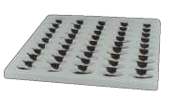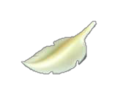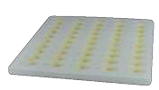

= Contains Milk = Contains Egg



***Hand Crafted Macarons***



|  |  |  |  |  |  |
| --- | --- | --- | --- | --- | --- |
| **CODE** | **DESCRIPTION** | **APP. SIZA** | **PACKAGING** | | |
|  | ***Hand Crafted Macarons*** |  | **tray** | **pc** | **total pc** |
| **FP009** | **Assorted Macarons Tray (Total 8 Flavours)**  馬卡龍 - 雜錦 (8 款)  Vanilla | Chocolate | Earl Grey | Lemon |  Passion Fruit | Raspberry | Salted Caramel | Coffee | Weight: 16gr/pc Dia: 4cm | 2 | 48 | 96 |
| **FP008A** | **Vanilla Macaron**  雲呢拿馬卡龍 | Weight: 16gr/pc  Dia: 4cm | 8 | 9 | 72 |
| **FP008B** | **Chocolate Macaron**  朱古力馬卡龍 | Weight: 16gr/pc  Dia: 4cm | 8 | 9 | 72 |
| **FP008D** | **Earl Grey Macaron**  伯爵茶馬卡龍 | Weight: 16gr/pc  Dia: 4cm | 8 | 9 | 72 |
| **FP008F** | **Lemon Macaron**  檸檬馬卡龍 | Weight: 16gr/pc  Dia: 4cm | 8 | 9 | 72 |
| **FP008G** | **Passion Fruit Macaron**  熱情果馬卡龍 | Weight: 16gr/pc  Dia: 4cm | 8 | 9 | 72 |
| **FP008H** | **Raspberry Macaron**  紅桑子馬卡龍 | Weight: 16gr/pc  Dia: 4cm | 8 | 9 | 72 |
| **FP008I** | **Salted Caramel Macaron**  海鹽焦糖馬卡龍 | Weight: 16gr/pc  Dia: 4cm | 8 | 9 | 72 |
|  | | | | | | |
| **Storage condition: -18 degree celsius**  **Remark: Shelf Life is 6 days at +4°C (To be consumed right away at Room Temperature)** | | | | | | |

= Contains Milk  = Contains Egg

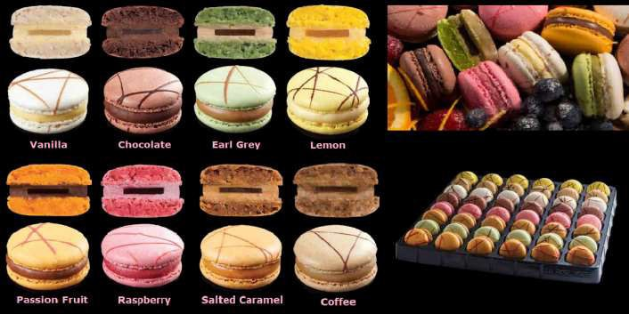

Pâtisserie et Chocolat Limited

##### Hand Crafted MINI Macarons



|  |  |  |  |  |  |
| --- | --- | --- | --- | --- | --- |
| **CODE** | **DESCRIPTION** | **APP. SIZE** | **PACKAGING** | | |
|  | ***Hand Crafted Mini Macarons*** |  | **tray** | **pc** | **total pc** |
| **FP009M** | **Assorted Mini Macarons Tray (9 Flavours)**  迷你馬卡龍 - 雜錦 (9 款)  Vanilla | Orange | Chocolate | Passion Fruit | Raspberry | Salted Caramel | Earl Grey | Coffee | Lemon | Weight: 6-7gr/pc Dia: 2.8cm | 2 | 63 | 126 |
|  | | | | | | |

***Assorted Plain Macaron (8 Flavours)***

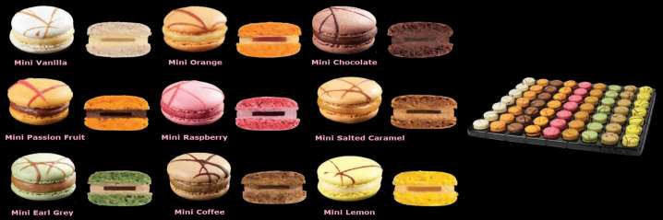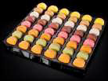

**CODE**

**DESCRIPTION**

**APP. SIZE**

**PACKAGING**

***Hand Crafted Plain Macarons***

**tray**

**pc**

**total pc**

**FP009A**

**Assorted Plain Macarons Tray (8 Flavours)**

馬卡龍- 雜錦(8款)

Vanilla | Chocolate | Earl Grey | Coffee | Lemon | Orange | Raspberry | Salted Caramel

**" No Painting , No Pâte de Fruit "**

Weight: 16gr/pc Dia: 4cm

2

48

96

FRD223

**Storage condition: -18 degree celsius**

**Remark: Shelf Life is 6 days at +4°C (To be consumed right away at Room Temperature)**

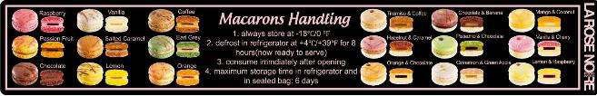

 = Contains Milk  = Contains Egg

Pâtisserie et Chocolat Limited

# Assorted Les Éclairons (8 flavours)



|  |  |  |  |  |  |
| --- | --- | --- | --- | --- | --- |
| **CODE** | **DESCRIPTION** | **APP. SIZE** | **PACKAGING** | | |
|  | ***Hand Crafted Les Éclairons*** |  | **tray** | **pc** | **total pc** |
| **FP015** | **Assorted Les Éclairons (8 Flavours)**  手指馬卡龍-雜錦 (8 款)  Mango & Chocolate | Black Currant & Coconut | Speculoos & Caramel | Vanilla & Raspberry | Pistachio & Morello Cherry | Toffee & Banana | Raspberry & Chocolate | Dark Chocolate & Vanilla | Weight: 12gr/pc L: 5cm  H: 2.5cm | 2 | 40 | 80 |
|  | | | | | | |

**Storage condition: -18°C (Shelf life from Production Date: 15 Months in Frozen)**

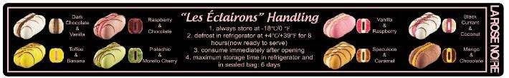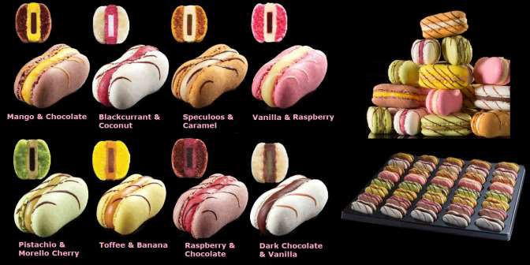

**\*\* Defrost at 4°C for 4-6 hours in its original sealed packaging \*\***

**\*\* To be consumed immediately after defrosting \*\***

= Contains Milk = Contains Egg



***Assorted Petit Cheese Cakes (6 flavours)***



|  |  |  |  |  |  |
| --- | --- | --- | --- | --- | --- |
| **CODE** | **DESCRIPTION** | **APP. SIZE** | **PACKAGING** | | |
|  | ***Petit Cheese Cakes*** |  | **tray** | **pc** | **total pc** |
| **FP013** | **Assorted Petit Cheese Cakes (6 Flavours)**  迷你芝士蛋榚-雜錦(6款)  New York | Marble | Caramel |  Blueberry | Chocolate | Raspberry | Weight: 17-18gr/pc Dia: 3.5 x H: 2cm | 2 | 48 | 96 |
|  | | | | | | |

***Assorted Les Carolines (6 flavours)***

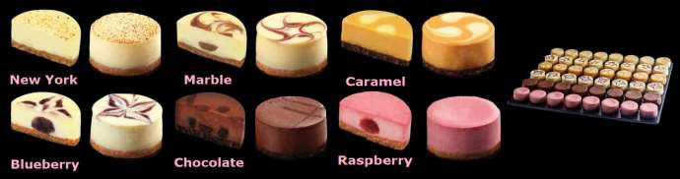

|  |  |  |  |  |  |
| --- | --- | --- | --- | --- | --- |
| **CODE** | **DESCRIPTION** | **APP. SIZE** | **PACKAGING** | | |
|  | ***Hand Crafted Les Carolines*** |  | **tray** | **pc** | **total pc** |
| **FP016** | **Assorted Les Carolines (6 Flavours)**  閃電泡芙 - 雜錦(6款)  Pistachio | Chocolate | Vanilla | Raspberry | Salted Caramel | Lemon | Weight: 13-15gr/pc L: 6 x H: 2.5cm | 3 | 24 | 72 |
|  | | | | | | |

**Storage condition: -18°C (Shelf life from Production Date: 15 Months in Frozen)**

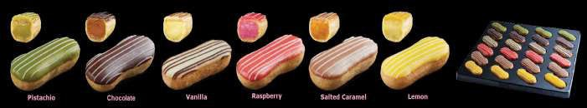

**\*\* Defrost at 4°C for 4-6 hours in its original sealed packaging \*\***

**\*\* To be consumed immediately after defrosting \*\***

= Contains Milk = Contains Egg



***Assorted Vegan Les Tartes Passion***

|  |  |  |  |  |  |
| --- | --- | --- | --- | --- | --- |
| **CODE** | **DESCRIPTION** | **APP. SIZE** | **PACKAGING** | | |
|  | ***Hand Crafted Vegan Les Tartes Passion*** | | **tray** | **pc** | **total pc** |
| **FP017VG** | **Assorted Vegan Les Tartes Passion (6 Flavours)**  圓形純素果撻-雜錦(6款)  Caramel Almond | Lemon | Pear Chocolate | Apple Vanilla | Chocolate Praline | Peach | Weight: 12-14gr/pc Dia: 3.7 x H: 1.6cm | 2 | 36 | 72 |
|  | | | | | | |

***Assorted Les ChouChous (6 flavours)***

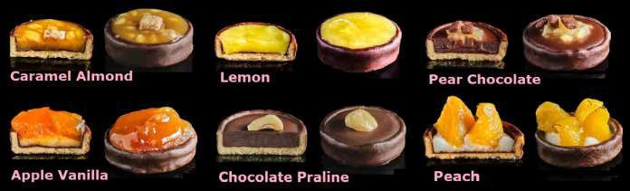

|  |  |  |  |  |  |
| --- | --- | --- | --- | --- | --- |
| **CODE** | **DESCRIPTION** | **APP. SIZE** | **PACKAGING** | | |
|  | ***Les ChouChous*** |  | **tray** | **pc** | **total pc** |
| **FP018** | **Assorted Les ChouChous (6 Flavours)**  圓形泡芙-雜錦(6款)  Double Raspberry | Double Chocolate |  Blackcurrant & Vanilla | Nutty Caramel & Vanilla |  Pistachio & Chocolate | Mango & Passion Fruit | Weight: 17-18gr/pc Dia: 4 x H: 3cm | 2 | 42 | 84 |
|  | | | | | | |

**Storage condition: -18°C (Shelf life from Production Date: 15 Months in Frozen)**

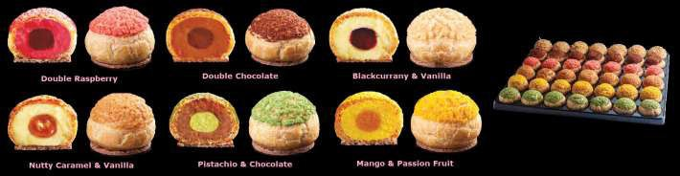

**\*\* Defrost at 4°C for 4-6 hours in its original sealed packaging \*\***

**\*\* To be consumed immediately after defrosting \*\***

= Contains Milk = Contains Egg



#### Assorted Les Cheeseclair (6 flavours)



|  |  |  |  |  |  |
| --- | --- | --- | --- | --- | --- |
| **CODE** | **DESCRIPTION** | **APP. SIZE** | **PACKAGING** | | |
|  | ***Les Cheeseclair*** |  | **tray** | **pc** | **total pc** |
| **FP025** | **Assorted Les Cheeseclair**  **(6 Flavours)**  迷你芝士蛋榚-雜錦(6款)  Blackcurrant | Raspberry | Mango | Passion Fruit | Banana | Coconut | Weight: 17-19gr/pc L: 5.2 x W: 2.5 x H: 1.6cm | 2 | 36 | 72 |
|  | | | | | | |

***Assorted Chocomisu (3 flavours)***

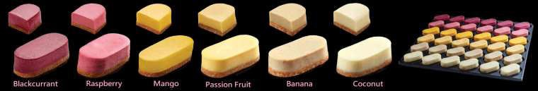

|  |  |  |  |  |  |
| --- | --- | --- | --- | --- | --- |
| **CODE** | **DESCRIPTION** | **APP. SIZE** | **PACKAGING** | | |
|  | ***Les Chocomisu*** |  | **tray** | **pc** | **total pc** |
| **FP034** | **Assorted Chocomisu  (3 Flavours)**  堤拉米蘇朱古力杯 - 雜錦 (3款)  Coffee | Dark Chocolate | Passion Fruit | Weight: 17-18gr/pc Dia: 3.3 x H: 2cm | 2 | 42 | 84 |
|  | | | | | | |

**Storage condition: -18°C (Shelf life from Production Date: 15 Months in Frozen)**

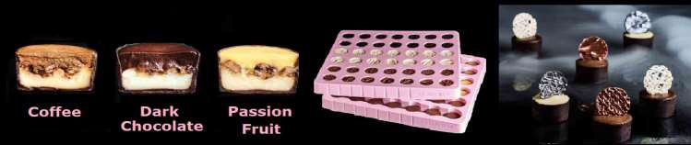

**\*\* Defrost at 4°C for 4-6 hours in its original sealed packaging \*\***

**\*\* To be consumed immediately after defrosting \*\***

= Contains Milk = Contains Egg



|  |  |  |  |  |  |
| --- | --- | --- | --- | --- | --- |
| **CODE** | **DESCRIPTION** | **APP. SIZE** | **PACKAGING** | | |
|  | ***Crystal Collection*** |  | **tray** | **pc** | **total pc** |
| **FP028** | Assorted Crystal Collection  (7 Flavours)  水晶朱古力 - 雜錦  Coffee | Blackcurrant | Lemon | Raspberry | Hazelnut | Salted Caramel | Passion Fruit | Weight: 8gr/pc | 2 | 63 | 126 |

***Assorted Champion Collection (3 flavours)***

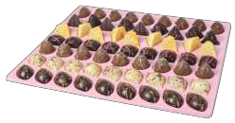

|  |  |  |  |  |  |
| --- | --- | --- | --- | --- | --- |
| **CODE** | **DESCRIPTION** | **APP. SIZE** | **PACKAGING** | | |
|  | ***Champion Collection*** |  | **tray** | **pc** | **pc** |
| **FP029** | Assorted Champion Collection  (3 Flavours)  方形朱古力 - 雜錦  Coffee | Hazelnut | Caramel  * 2 Trays per flavour * | Weight: 8gr/pc | 6 | 27 | 162 |

***Assorted Venetian Collection (3 flavours)***

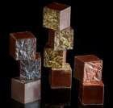

|  |  |  |  |  |  |
| --- | --- | --- | --- | --- | --- |
| **CODE** | **DESCRIPTION** | **APP. SIZE** | **PACKAGING** | | |
|  | ***Venetian Collection*** |  | **tray** | **pc** | **total pc** |
| **FP030** | Assorted Venetian Collection  (3 Flavours)  錐形朱古力 - 雜錦  Coconut | Raspberry | Mango  * 1 Trays / Flavour * | Weight: 12gr/pc | 3 | 24 | 72 |

**Storage condition: -18°C (Shelf Life from Production Date: 15 Months Frozen)**

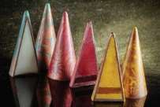

**\*\* defrost at 4°C for 4 hours in its original sealed packaging \*\***

**\*\* consume immediately after opening \*\***

= Contains Milk = Contains Egg



|  |  |  |  |  |  |
| --- | --- | --- | --- | --- | --- |
| **CODE** | **DESCRIPTION** | **APP. SIZE** | **PACKAGING** | | |
|  | ***Rainbow Collection*** |  | **tray** | **pc** | **pc** |
| **FP032** | Assorted Rainbow Collection  (3 Flavours)  彩虹朱古力 - 雜錦  Passion Fruit | Lime | Raspberry  * 2 Trays per flavour * | Weight: 7-8gr/pc | 6 | 27 | 162 |

***Assorted Chocolate Logs (5 flavours)***

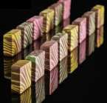

|  |  |  |  |  |  |
| --- | --- | --- | --- | --- | --- |
| **CODE** | **DESCRIPTION** | **APP. SIZE** | **PACKAGING** | | |
|  | ***Chocolate Logs Collection*** |  | **tray** | **pc** | **pc** |
| **FP033** | Assorted Chocolate Logs  (5 Flavours)  木頭朱古力 - 雜錦  Blackcurrant | Passion Fruit | Lemon | Orange | Raspberry | Weight: 7-8gr/pc | 2 | 60 | 120 |

***Assorted Moon (3 flavours)***

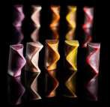

|  |  |  |  |  |  |
| --- | --- | --- | --- | --- | --- |
| **CODE** | **DESCRIPTION** | **APP. SIZE** | **PACKAGING** | | |
| **NEW!** | ***Moon Collection*** |  | **tray** | **pc** | **pc** |
| **FP035** | Assorted Moon Collection  (3 Flavours)  月亮朱古力 - 雜錦  Vanilla | Mango | Green Tea  * 2 Trays per flavour * | Weight: 8-9gr/pc | 6 | 27 | 162 |

**Storage condition: -18°C (Shelf Life from Production Date: 15 Months Frozen)**

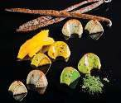

**\*\* Defrost at 4°C for 4 hours in its original sealed packaging \*\***

**\*\* Shelf life of 7 days applied for keeping at +18C in a dry cool place. \*\***

= Contains Milk = Contains Egg





**Pâtisserie et Chocolat Limited Product Delivery Guideline**

31st January 2023

|  |  |  |  |
| --- | --- | --- | --- |
| **Product Category** | **Shelf-Life Period (P = Production)** | **Storage Condition** | **Approximate Shelf-Life upon delivery**  **(inclusive of day of delivery)** |
| Frozen Macaron, Les Éclairons | P + 18 months | **- 18ºC** or below | 9 months |
|  |  |  |  |
| Frozen Dessert | P + 15 months | **- 18ºC** or below | 8 months |
|  |  |  |  |
| Frozen VIP Bread | P + 9 months | **- 18ºC** or below | 3 months |
|  |  |  |  |
| Frozen Croissant & Danish | P + 9 months | **- 18ºC** or below | 3 months |
|  |  |  |  |
| Tart shells with coating | P + 12 months | + 18ºC or below | 6 months |
|  |  |  |  |
| Basket & Cones | P + 8 months | + 4ºC or below | 3 months |
|  |  |  |  |
| Chocolate Creations _ 69% Chocolate Shells, Chocolate Leaves, Chocolate Universe, Chocolate Creations | P + 18 months | + 4ºC to 16ºC | 9 months |
|  |  |  |  |
| Frozen Bonbons | P + 15 months | **- 18ºC** or below | 8 months |

Should there be any question, please feel free to contact our office. Thank you for your attention.

**Pâtisserie et Chocolat Limited**

302 Corporation Square, No.8 Lam Lok Street, Kowloon Bay, Kowloon, Hong Kong Tel: 2754 2355 / Fax: 2795 7473 Email: [office@baker-patissier.com](mailto:office@baker-patissier.com)

Delivery Schedule 送 貨 詳 情



All products will be delivered according to the delivery schedule assigned to your locations. There is no delivery on Sunday.

The order cut-off time is 1pm for the following scheduled delivery day (except for special items that need 2 or 3 working-days’ notice) and 12 noon on Friday for delivery on Saturday and Monday, no delivery on Sunday.

Our internal sales team will inform your team in advance for the public holiday arrangements as we make deliveries on public holidays.

We accept ordering by **email to** [**Office@baker-patissier.com**](mailto:Office@baker-patissier.com) or by **whatsapp to 27542355**. This line is for

**placing order** and **COD payment only**.

|  |  |  |
| --- | --- | --- |
| Area | Min. Invoice Amount | Delivery Charge |
| per Delivery | (if min. order amount is not reached) |
| 地區 | 每 次 最 低 | 如 訂 貨 額 不 足, |
| 訂 貨 限 額 | 均 會 收 取 |
| 送 貨 費 用 如 下 |
| Commercial Area 商 業 區 | **$800** | **$250** |
| Airport Area 機 場 範 圍 | **$1,000** | **$350** |
| Shatin/ Ma On Shan/ Tai Po Area  沙 田/ 馬 鞍 山/ 大 埔 範 圍 | **$800** | **$350** |
| Tuen Mun/ Tin Shui Wai/ Yuen Long/ Tung Chung/ Sheung Shui Area  屯 門/ 天 水 圍/ 元 朗/ 東 涌/ 上 水 範 圍 | **$1,000** | **$350** |

**Pâtisserie et Chocolat Limited**

302 Corporation Square, No.8 Lam Lok Street, Kowloon Bay, Kowloon, Hong Kong Tel: 2754 2355 / Fax: 2795 7473 Email: [office@baker-patissier.com](mailto:office@baker-patissier.com)